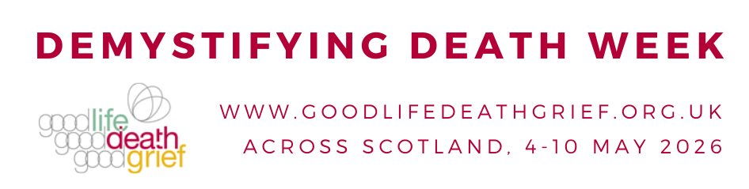

Social Media Ideas
Your support for Demystifying Death Week is much appreciated. Below are some ideas for social media posts on a range of issues.
You can access some pictures/flyers/infographics for posting here: https://www.goodlifedeathgrief.org.uk/ddweekcommspack26/

General ideas
Demystifying Death Week is about shining a light on death, dying and bereavement in Scotland. Scotland should be a place where everyone can help someone who is caring, dying or grieving. #DemystifyDeath

Check out the list of events taking place across Scotland this week to mark #DemystifyDeath Week: https://www.goodlifedeathgrief.org.uk/blogs/demystifying-death-week-2026/

Personal reflection
Check out this online #BeforeIDie wall – a beautiful collection of people’s hopes and dreams. #DemystifyDeath https://www.goodlifedeathgrief.org.uk/content/before-i-die/
For Demystifying Death Week, a powerful and challenging series of portraits and personal stories exploring the idea that as people’s health deteriorates, care and support comes in many guises https://www.goodlifedeathgrief.org.uk/members-resources-village/ #DemystifyDeath #ItTakesAVillage

Children and young people
Would your school like to do more to support young people and staff who are bereaved? Check out the Bereavement Charter Mark for Schools. https://www.goodlifedeathgrief.org.uk/about-charter-mark-schools/

What do children want to know about death? Check out this 60-second film. https://vimeo.com/546439507/378fd902fd #DemysitfyDeath

This week is Demystifying Death Week. A good time to share these great resources for schools on supporting young people who are bereaved - https://www.goodlifedeathgrief.org.uk/for-schools/ #DemystifyDeath

How do you talk to children about death? There are some helpful tips in this free information leaflet: https://www.goodlifedeathgrief.org.uk/file-download/64/8_-_Information_to_help_you_help_children_understand_death.pdf #DemystifyDeath

Dying
What support can a friend or family member offer to someone who is caring, dying or grieving? If you’re interested in learning more, check out the End of Life Aid Skills for Everyone course. It is free & takes a few hours over 4 weeks. https://www.goodlifedeathgrief.org.uk/plan-illness-ease/ #DemystifyDeath

#DemystifyingDeath Week is an opportunity to learn more about dying and bereavement. In this 1-minute film @drkathrynmannix explains how someone’s breathing can change when they are dying. https://vimeo.com/546438682/ee62f17d5f #DemystifyDeath

“Dying is unpredictable…However, there are certain bodily changes that show a person is likely to be close to death.” This online resource explains some of the bodily changes that can happen in the last days and hours of someone’s life. #DemystifyDeath https://www.goodlifedeathgrief.org.uk/content/what-happens-when-someone-is-dyi/

In this beautiful short animation ‘Dying for Beginners’ Kathryn Mannix guides you gently on a step by step journey through the process of dying. #DemystifyDeath https://www.youtube.com/watch?v=ayMhA1pRLeY

A sensitive explanation of what ‘normal dying’ can look like from @DrKathrynMannix https://www.bbc.co.uk/ideas/videos/dying-is-not-as-bad-as-you-think/p062m0xt #DemystifyDeath

Planning Ahead
“I’m going to get my house in order, and explain how I went about it, how it felt, and what I learnt... Hopefully, I won’t die before I’m finished. But you never know…?” The Reluctant Planner’s Guide to Death and Dying: https://www.goodlifedeathgrief.org.uk/blogs/planning/ #DemystifyDeath

Planning when you’re healthy means there is less to think about if you get ill. Some good resources on planning ahead, including future care planning, power of attorney and DNACPR are available here - https://www.goodlifedeathgrief.org.uk/plan/

#DemystifyDeath week encourages people to think about planning ahead for future ill health and dying. Check out this film from the Open University exploring the importance of planning for the future https://www.youtube.com/watch?v=A0b_PW-ENf8

Should everyone have an end of life plan? A fantastic short film from @bbcideas and @OUfree learning – great for watching, teaching and sharing. #DemystifyDeath https://www.bbc.co.uk/ideas/videos/should-everyone-have-an-end-of-life-plan/p099x2yh

Would you like to know more about ‘Do Not Attempt CPR’ decisions? This TEDx talk by Dr Kathryn Mannix explores use of CPR in different circumstances. #DemystifyDeath https://www.youtube.com/watch?v=Pn__lDD5q9g&t=296s

After a death
This gentle short animation explores different burial practices https://view.genial.ly/65422e2d4dc441001160bc03 #DemystifyDeath
This is #DemystifyDeath Week. This website provides information about the practicalities to be considered after someone dies and links to places you can go for support. https://www.goodlifedeathgrief.org.uk/support-after/

Bereavement and Grief

Living with grief can be incredibly tough – mentally, emotionally and physically – but having the right knowledge and resources can make a big difference. @GoodGriefFest has a fantastic collection of resources here: https://www.goodgrieffest.com/resources/ #DemystifyDeath

Want to support someone who is bereaved, but not quite sure what to say? This series of five short video tutorials from @Sue_Ryder explore what grief is like and how you can support others who are grieving.
https://www.sueryder.org/how-we-can-help/bereavement-information/grief-kind/griefkindclasses
#DemystifyDeath

Workplaces and bereavement
Workplaces should be supportive of bereaved staff. These resources from @lifedeathgrief can help: https://www.goodlifedeathgrief.org.uk/members-resources-workplaces/
#DemystifyDeath

What can you do if a colleague has been bereaved? This leaflet from @lifedeathgrief will help you think through some ways you might be able to show support. https://www.goodlifedeathgrief.org.uk/file-download/47/12_-_Death_in_the_Workplace_Final.pdf

Is your workplace doing what it can to support grieving staff? Check out the Bereavement Charter Mark for Employers in Scotland – the accompanying resources guide employers on supporting bereaved employees.
https://www.goodlifedeathgrief.org.uk/about-charter-mark-employers/
BecauseGriefMatters #DemystifyDeath

