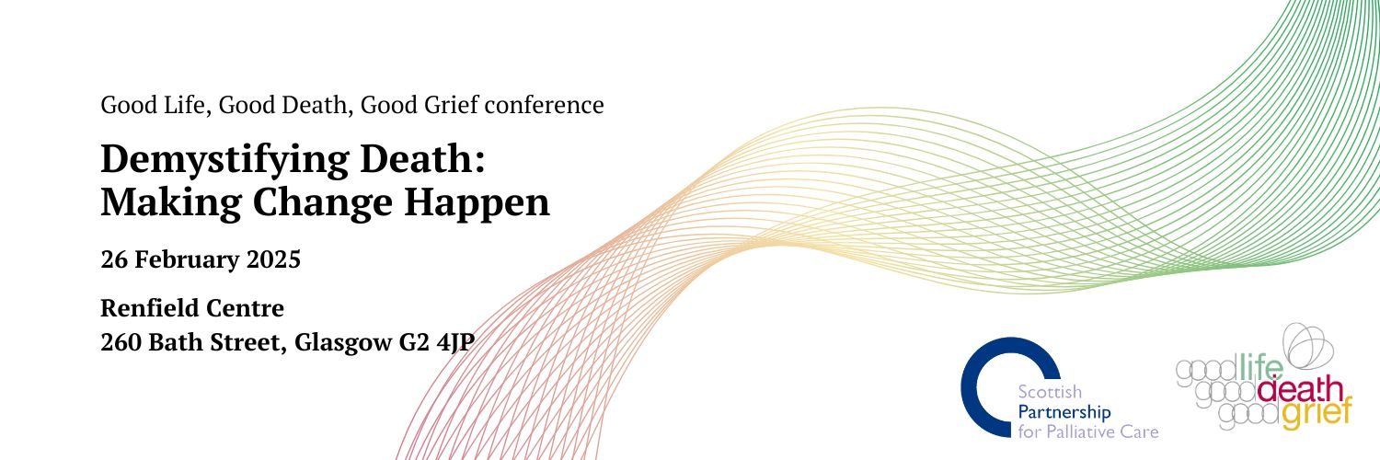
Conference Programme

09.30 Registration and coffee (Foyer, Main Hall)

10.00 Welcome (Main Hall)
Introduction to the day

10.15 Compassionate communities: Everything, everywhere, all at once
(Main Hall)
Professor Allan Kellehear, Professor in Health & Social Care, Northumbria University

10.45 Different approaches to getting stuff done (Main Hall)
Creating more ‘grief aware’ schools - piloting a Bereavement Charter Mark for Primary Schools in Scotland
Donna Hastings, Head of Patient and Family Support, St Columba’s Hospice Care

Runforever, humanising responses to grief and loss in a prison environment
Paolo Maccagno, Founder and CEO, Runforever

Arts and culture: creating compassionate communities in which to live, die and grieve
Dominic Campbell, Arts and Cultural Engagement Lead, Irish Hospice Foundation (speaking via video link)

11.25 Coffee Break (Main Hall)

11.55 Exploring and addressing the impact of financial hardship on
experiences of dying and bereavement (Main Hall)
Bringing together research, communications, policy and campaigning to make change happen
Amy Dalrymple, Associate Director for Policy and Public Affairs, Marie Curie Scotland

Funeral poverty – stories from Scotland
Emma Kelso– Senior Funeral and Bereavement Advisor, Caledonia Funeral Aid

12.30 Kathryn Mannix (Main Hall, speaking over video link)

13.00 Lunch (Main Hall)

14.00 Breakout Sessions

Delegates can choose to attend one of the following sessions:

Breakout session A:
Unleashing creativity and conversations
With John Martin Fulton, Artist

Explore how to use art to create inclusive and supportive group spaces where meaningful conversations can happen. No artistic experience necessary - this is more about relaxing and experimenting. Delegates can try out some art activities around personal reflections on death and grief. So be ready to get creative and reflective.

Breakout session B:
Bringing Death Back into Life
With Kate Clark, Pushing up the Daises

When someone close to us takes their last breath, we have choices about what happens next. One of these is to employ a funeral director to take care of their body and arrange their funeral. Another is to immerse ourselves in the space between their last breath and their funeral. Join Kate Clark to explore the possibilities, legalities, practicalities, fears and unknowns of what is currently an unusual choice in Scotland. This session also explores the impact on the living of the choices made in this space and how this may contribute to the Lancet Commission call for death to be recognised as not only normal, but valuable.

Breakout session C:
Sharing ideas and inspiration for Demystifying Death Events
With Jennifer Watt, NHS Greater Glasgow & Clyde.

Thinking of organising an event for Demystifying Death Week or the To Absent Friends Festival this year? This workshop is a chance to share your experiences, reflections and questions, and bounce ideas off others - what makes a good event? What challenges do you face? What resources help? A chance for those new to this area to learn from others; a chance for experienced event organisers to gain some new ideas and inspiration.

Breakout session D:
Demystifying Spiritual Care – What actions count?
With Gerrie Douglas-Scott, Director and Spiritual Care lead of Celebrate People, and Spiritual Care Consultant at Ardgowan Hospice.

This workshop will aim to support participants to make spirituality and spiritual care something real and something actionable. From one to one small acts of kindness to radical organisational development, it permeates everything from end of life accompaniment to every day care provision. It even includes supporting religious faith and belief, but not always.

15.10 Creating spaces for compassionate conversations – a panel
discussion (Main Hall)

16.15 Conference ends.

