**Small Grants Programme**

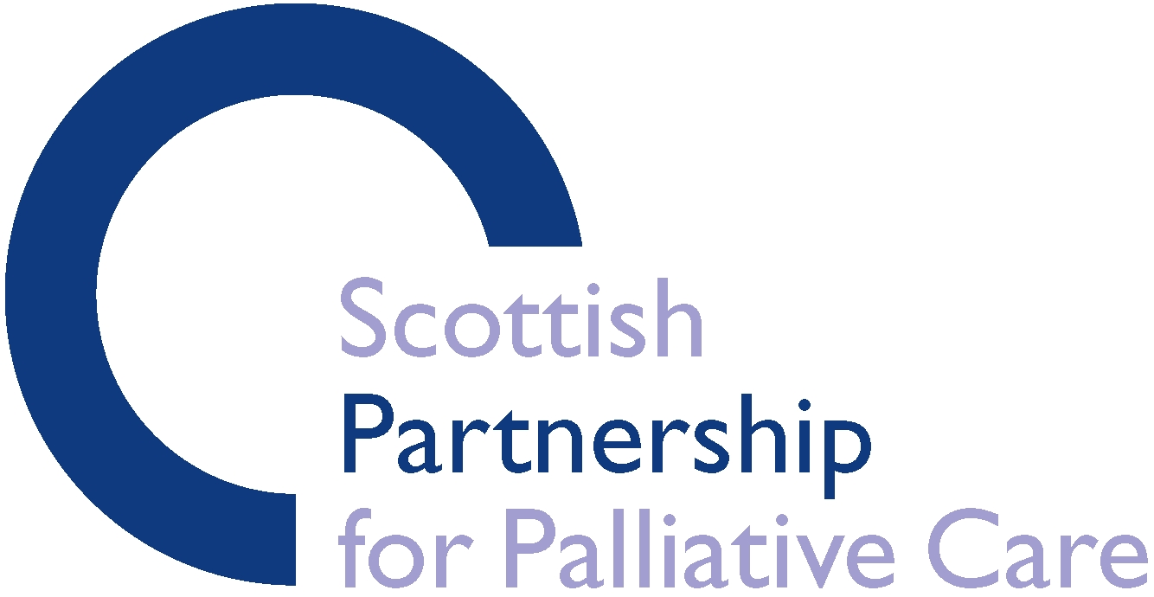

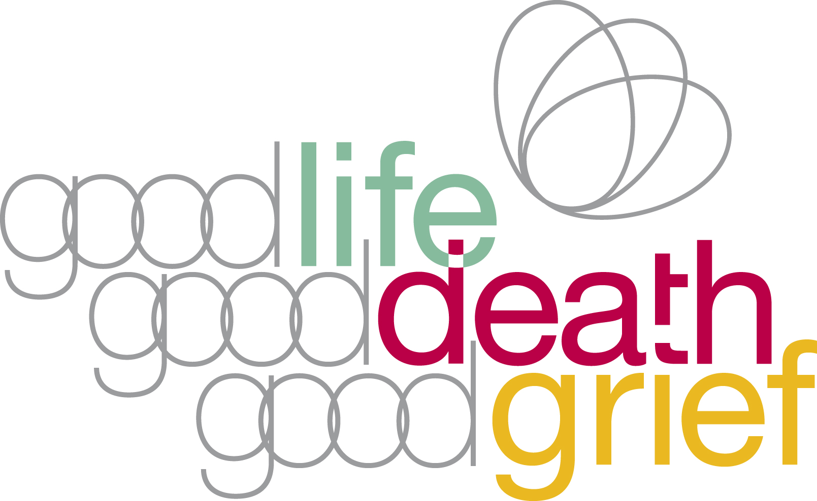

**Demystifying Death Week**

**Spring 2024**

**Guidance notes for applicants**

**Background**

*Good Life, Good Death, Good Grief* is an alliance of organisations and individuals who want Scotland to be a place where people help each other through the difficult times that can come with death, dying, loss and care.

We believe that people usually want to do the right thing when someone they know is affected by ill health, death or grief.

But sometimes other things get in the way – lack of knowledge, time, experience or confidence can mean people don’t offer help. Structures, culture and conventions can create barriers to individuals acting on their intuition.

Good Life, Good Death, Good Grief wants to address this. We want to create a Scotland where everyone knows how to help when someone is dying or grieving.

We want Scotland to be a place where:

* People are well-informed about the practical, legal, medical, financial, emotional and spiritual issues associated with death, dying and bereavement.
* There are adequate opportunities for discussion of these issues, and it is normal to plan for the future.
* Public policies acknowledge and incorporate death, dying and bereavement.
* Health and social care services support planning ahead and enable choice and control in care towards the end of life.
* Communities and individuals are better equipped to help each other through the hard times which can come with death, dying and bereavement.

More information about the aims, visions and values of *Good Life, Good Death, Good Grief* is available here: [www.goodlifedeathgrief.org.uk](http://www.goodlifedeathgrief.org.uk)

**Q1. What will the small grants programme fund?**

This small grants fund has been set up to support GLGDGG members to participate in *Demystifying Death Week,* running 6-12 May 2024.

Demystifying Death Week is about giving people knowledge, skills and opportunities to plan and support each other through death, dying, loss and care.

We’re seeking applications for events that take place in DD Week that meet one or more of the following aims:

* Help people to find ways of dealing with their own experiences of death, dying and bereavement;
* Help individuals and communities to support those who are experiencing difficult times associated with death, dying and bereavement;
* Support NHS and social care staff and volunteers to work compassionately and constructively with those who are dying or have been recently bereaved;
* Help people to make practical preparations for their death, for example Will, Power of Attorney and Advance Care Planning;
* Promote openness/discussion of death, dying and bereavement.

Events that have taken place in previous years are listed on the GLGDGG website, and the website also provides free event resources:

<https://www.goodlifedeathgrief.org.uk/content/ddweekevent/>

We recognise that approaches to this are likely to be varied, and encourage creative and innovative ideas that are appropriate to local groups and communities.

**Q2. Who can apply?**

The small grants programme can only provide funding for organisations. We are unable to provide funding direct to individuals. If you are an individual who would like to carry out some work who may require funding to help, please either link up with an organisation in your local area who you think may be keen to be involved or get in touch with us by email at [info@goodlifedeathgrief.org.uk](mailto:info@goodlifedeathgrief.org.uk) to see if we can help.

Only members of Good Life, Good Death, Good Grief can apply. It is free to join GLGDGG, and you can do so here: <https://www.goodlifedeathgrief.org.uk/content/sign_up/>

Organisations can only apply for funding once within this Spring 2024 funding programme. If you are a small branch of a larger organisation please contact your head office to check that they are happy for your branch to apply.

**Q3. How much can be applied for?**

The maximum sum available through the small grants programme is £250. We have a limited amount of funding available so please think carefully about your project or event and obtain indicative costings to submit with your proposal. We are more likely to fund your proposal if we can see that it has been well thought out and properly costed. There is no minimum level of grant.

**Q4. What can a grant pay for?**

A grant can be applied for to allow an organisation to undertake, within Scotland, a project, event or any other activity that engages with their local community to take part in *Demystifying Death Week, 6-12 May 2024*. Examples of the types of things that can be included in an application are:

* Costs for booking a venue to host an event.
* Food and refreshments for delegates attending an event (the purchase of alcohol with the grant funding is not permitted).
* Printing costs for materials (leaflets, posters etc).
* Other equipment that might be needed as part of a project or event. Please note that any equipment purchased must remain the property of the organisation and must not be transferred to an individual.
* Training costs or volunteer expenses.
* Publicity costs involved in promoting your event.

Here are some examples of things that can’t be funded:

* Activities that have happened before your grant is received.
* Costs associated with making an application for funding.
* Day to day running costs for the organisation or activity that the organisation would normally be expected to carry out.
* Any fundraising activity for the organisation.
* Projects that take place outside Scotland.
* Projects or events aiming to promote a particular religious, moral, ethical or political stance at the exclusion of others.

**Q5. How can you apply?**

To apply for a grant, you will need to complete our short application form which can be downloaded from our website: <https://www.goodlifedeathgrief.org.uk/content/ddwsmall_grants2024/>

Please email your completed form to: [samara@palliativecarescotland.org.uk](mailto:samara@palliativecarescotland.org.uk)

The deadline for receipt of completed applications is **Friday 22 March 2024.** We will aim to inform applicants whether or not they have been successful by **Friday 29 March 2024.**

**Q6. What happens next?**

Once we have received your application and the closing date has passed, we will give it consideration and let you know if we are able to provide funding. As part of the process of considering your application we may get in touch with you directly or may contact your head office if you are a branch applying on behalf of a larger organisation. If we are unable to provide funding for all or part of your application we will let you know the reason(s) why.

If your bid is successful, you should expect to receive the monies (by BACS) to fund your project, event or activity within a further week.

By applying for funding you are also agreeing to:

* provide 300 words about the event and a photo, to share on the Good Life, Good Death, Good Grief website event listing, by 12 April 2024.
* Providing a brief report (template will be provided), photos and receipts for expenditure after the activity or event has taken place.

**Q7. Why do I need to report back after the event?**

Receiving an activity report provides assurances that SPPC monies are being spent in an appropriate manner, and helps us to learn from, share and develop our awareness of local activity.

We may also use reports as part of our publicity work. If you are able to provide photographs or obtain media coverage, please let us know as we may be able to further showcase your activity through our website, newsletter, social media or other networks.

**CBC House, 24 Canning Street,**

**Edinburgh, EH3 8EG**

**Tel: 0131 272 2735**

**Fax: 0131 272 2800**

**info@goodlifedeathgrief.org.uk**

**www.goodlifedeathgrief.org.uk**

Good Life, Good Death, Good Grief is an initiative of the Scottish Partnership for Palliative Care,

a Company Limited by Guarantee. Registered in Scotland No: 133003. Registered Charity SC017979