The Conversation Project - Report
Victoria ACH
Wednesday 3rd October 2012

Background

Following the publication of “Living and Dying Well: a national action plan for palliative and end of life care in Scotland” (1) in 2008, a short life working group was established to address the exploration of ideas and issues for addressing palliative and end of life care from a public health and health promotion perspective. The vision of this group was to create a Scottish society in which:

- people are able to talk about death and deal with related issues in a constructive way
- children grow up treating dying as an inevitable part of ordinary life
- people are comfortable using words such as “death”, “dead” and “dying”, and are able to make choices relating to their own dying and death
- health and social care professionals and volunteers in all care settings feel able to have discussions relating to death, dying and bereavement with patients and families, and with colleagues
- communities of all kinds are empowered to provide effective support to those dealing with death, dying, bereavement and loss.

To reach this vision, they set out ten recommendations in their final report (2). Recommendation one was to establish a broad-based coalition to lead and co-ordinate further work in this area. The coalition should be tasked specifically with raising public awareness and promoting community involvement in the issues of death, dying and bereavement. This coalition has since been established under the Scottish Partnership for Palliative Care, called “Good Life, Good Death, Good Grief”. As part of their work, they have commissioned a number of resources to be used as practical tools in raising acceptance to talk about death.

Local Event

In Glasgow, a local partnership between NHS Greater Glasgow and Clyde and the Prince and Princess of Wales Hospice identified the potential to run an event that encouraged people to start to think about having difficult conversations with loved ones, and would provide them with resources that would help them to do so.

It was agreed to hold the event within the atrium at the new Victoria hospital. The hospital has a high footfall daily, and the atrium is beside the main entrance and the Aroma café meaning that many staff and visitors pass through there. This would allow an opportunity to talk to a variety of people about the topic.

Throughout the day there was a multi disciplinary staff team available to discuss different aspects of end of life care and offer support and signposting. The team included hospice staff from the Prince and Princess of Wales Hospice, Anticipatory Care Planning nurses and Health Improvement staff.

Resources

The promotional material and resources were set up along one wall of the atrium area. There was a TV monitor showing the DVD produced by “Good Life, Good Death, Good Grief” called “20 takes on death and dying”. This DVD was filmed in Paisley and Elgin and has some frank discussions about death from a very real perspective. It was felt that this would be a good attraction to get people coming over to the table, and was the first thing on display.

A range of physical resources was available for people to take away with them. These included the range of leaflets produced by “Good Life, Good Death, Good Grief”, copies of the NHS GGC booklet “My thinking ahead and making plans” and a Scottish adaptation of “The Conversation Project” starter kit.

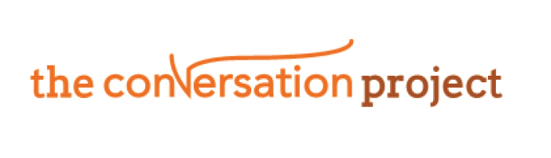
The Conversation Project, from the USA, is dedicated to helping people talk about their wishes for end-of-life care, and the starter kit was designed to help individuals think about what they wanted to discuss before starting any conversations. The project team obtained permission from the project to adapt and use the kit at the event in Glasgow.

Finally, a display of colourful images and wording was projected onto the side wall. This was highly visible and worked as a way of opening conversation with people.

Who we spoke to

Over the course of the day the staff had conversations with 47 people. These can be broken down as follows:

 | Male | Female | Total
Patient | 5 | 12 | 17
Family/Carer | 2 | 7 | 9
Staff | 2 | 8 | 10
Unidentified | 3 | 8 | 11
Total | 12 | 35 | 47

The content of the conversations varied and everyone left with some of the resources, depending on their need. Some people acknowledged that it was a difficult subject to discuss, but also a very important one. The clinical staff were also able to signpost patients and families to palliative care services and respond to specific questions. Encouragement was given to “start the conversation”; this was acknowledged as being helpful.

Most conversations lasted between 5 and 15 minutes, however a couple of more complex cases lasted around half an hour. There was additional private space available where people could be taken if needed, which was used on one occasion. Three key themes from the conversations were:

- How to start the conversation
- Post bereavement support
- Figuring out what was important in the last few months of life

In addition to the 47 people with whom the team talked, many more stopped for a short while to look at the material.

Future Activity

The numbers reached on the day was better than anticipated, and the participation in meaningful conversation encouraging. The future plan is to repeat this type of event in the Victoria as well as piloting them in other areas, starting with Stobhill ACH. A large contributing factor to the success of the event was the involvement of the hospice, and therefore it is hoped that other local Hospices will be able to get involved for the events in other areas. In addition, to reach wider numbers of the public future scoping should be done to identify the potential to hold similar events in local communities too.

Claire Donaghy
October 12

