Awareness Events and “Before I Die” Walls
Wednesday 15 May 2013 at Royal Alexandra Hospital, Paisley
Thursday 16 May 2013 at Glasgow Royal Infirmary

Background
Good Life, good Death, Good Grief is an Alliance of organisations and individuals that want to work together to:
- Raise public awareness of ways of dealing with death, dying and bereavement
- Promote community involvement in death, dying and bereavement
13-19 May 2013 was Scotland’s first Good Life, Good Death, Good Grief Awareness Week. This one week in May saw a hive of activity, with a range of events and activities taking place across the country. The purpose of this was to raise awareness of the need for Scotland to become a place where people can be open about death, dying and bereavement.

Local Event

In Glasgow, following the success of previous events held at the Victoria and Stobhill ACH, it was agreed to hold similar events at the Royal Alexandra Hospital and the Glasgow Royal Infirmary. In addition to having information resources available at both of these events, it was decided to also include “Before I Die” walls. These walls offer people the opportunity to write one thing that they would like to do before they die, and have proven to be successful around the world.

As before, the events were held in the foyers of the hospitals, next to the main entrance. Throughout both days there was a multi disciplinary staff team available to discuss different aspects of end of life care and offer support and signposting. The team included staff from St Vincent’s and Marie Curie Hospices, Anticipatory Care Planning nurses and Health Improvement staff.

Resources

The Good Life, good Death, Good Grief team had provided a pull up display banner that attracted the attention of passers by. The “Before I Die” Wall was positioned beside the banner and promotional material and resources were set up on a table next to it. There was also a laptop that displayed either a graphic presentation or the DVD called “20 takes on death and dying”. This DVD was filmed in Paisley and Elgin and has some frank discussions about death from a very real perspective.

A range of physical resources was available for people to take away with them. These included the range of leaflets produced by “Good Life, Good Death, Good Grief”, copies of the NHS GGC booklet “My thinking ahead and making plans” and some literature from the hospice. There were also information cards about the website www.finalfling.com.

The “Before I Die” wall was a huge success. It worked as a great conversation opener and allowed the teams to “hook” people into a conversation. The success of it is reflected in the figures.

Who we spoke to

At the RAH the team had conversations with 91 people. These can be broken down as follows:

 | Male | Female | Total
Patient | 7 | 12 | 19
Family/Carer | 5 | 12 | 19
Staff | 16 | 35 | 51
Unidentified | 3 | 1 | 4
Total | 31 | 60 | 91

At the GRI the team had conversations with 135 people:

 | Male | Female | Total
Patient | 26 | 30 | 56
Family/Carer | 8 | 16 | 24
Staff | 27 | 25 | 52
Unidentified | 0 | 3 | 3
Total | 61 | 74 | 135

These numbers are much higher than at previous events in the Ambulatory Care Hospitals. This is partly due to size of hospital but primarily down to the “Before I Die” wall allowing people to engage in conversation in a non threatening way. As before, not everyone was willing to talk to the team and this was handled sensitively, acknowledging that not everyone will feel able to have this kind of discussion.

As at previous events, some people were happier to talk about death than others. The team engaged with a much higher number of staff at these events – the majority of whom were ward staff (which the ACHs don’t have). These conversations allowed the team to signpost to relevant resources and services. Some of the areas of the hospitals requested further resources and training as a result of talking to the team.

The 'My thinking ahead and making plans' booklet was discussed and given to people who wanted it. All the resources were handed out as appropriate following discussions and some people were signposted to other external services for further help.

Most conversations lasted between 2 and 5 minutes. There was additional private space available where people could be taken if needed, although this wasn’t required on either of the days.

The key themes from the conversations were:
- Post bereavement support (lack of services)
- Making a Will
- Organ Donation
- Talking about your wishes

Before I Die Wall

The “Before I Die” Wall was undoubtedly a huge success. Although the initial purpose of these walls was as an arts installation, the teams at these events used them as a tool to start a conversation around society and death. This worked well for most people. At both events the walls were filled easily throughout the day and even if people didn’t want to add to the wall, they would read what other people had written which would open up the conversation.

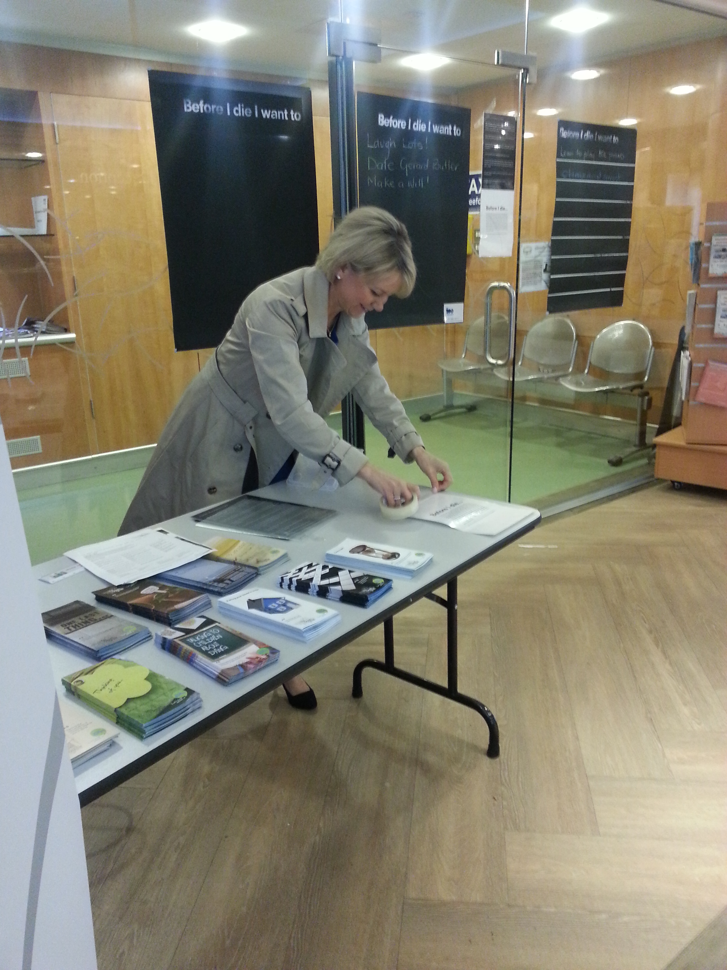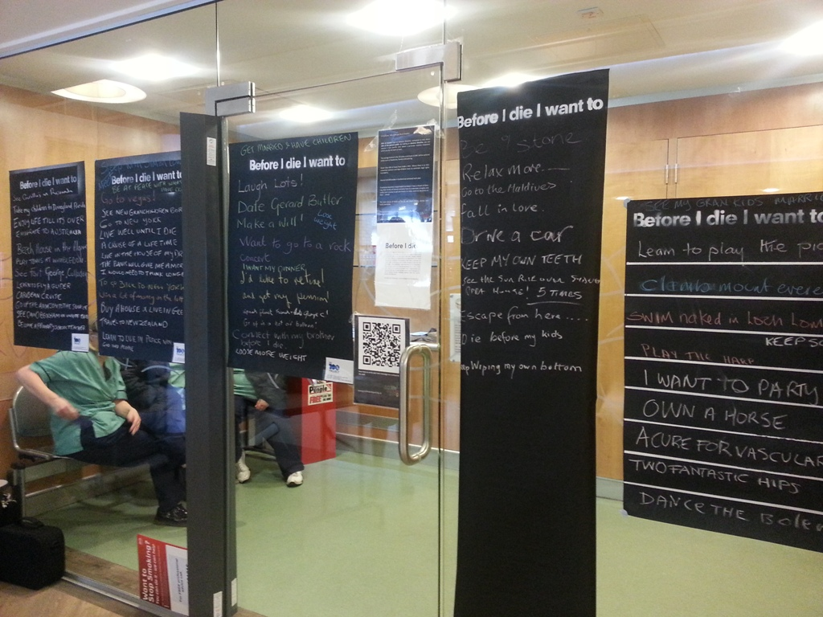

Contributions to the wall included dreams of travel destinations, unfulfilled career desires and hopes for future retirement. There were artistic aspirations and wishes to meet (and date) celebrities. Only one or two of suggestions were unsuitable to go on the wall! Future events of this kind would benefit from having the “Before I Die” wall available to increase the number of interactions.

