

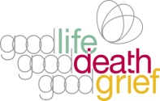



**Instructions:** Cut along the dashed line – **this side is the front**

➀ Fold and unfold across both diagonals

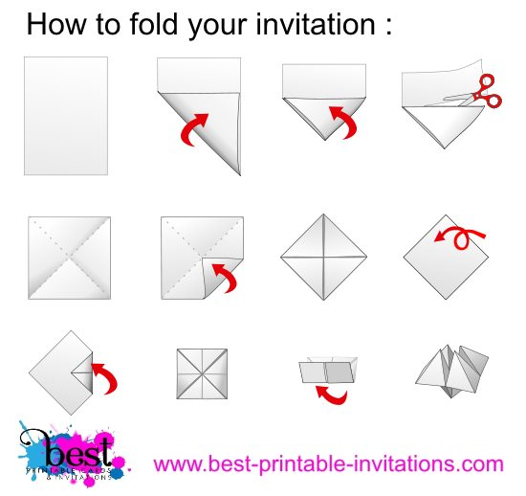➁ With back facing up, fold

the corners to the centre

➂ Turn it over ➀ ➁ ➂

➃ Fold the corners to

the centre again

➄ Fold one half over the

other half to form a rectangle

➅ Push your fingers up under ➃ ➄ ➅

the loose flaps

**Imagine being seriously ill...**

**What would you want?**

**Would your priorities change?**

**Would there be things you wish you’d told someone?**

Making plans when you’re healthy means there is less to think about if you get sick. It also helps those close to you to know they are carrying out your wishes.

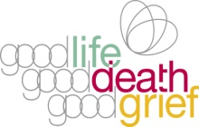

More information about these and other related issues is available at:

<https://www.goodlifedeathgrief.org.uk/content/advance_care_planning/>

**Tell People what Matters to You**

**It is important to talk to family, friends and health & social care professionals about** your concerns, values, expectations and preferences. As well as discussing medical aspects, you

might want to talk about the other things that matter to

you – l**ike who will walk your dog, or mow your**

**lawn, or bring you a whisky before bed.**