Good Death Week Grants – Application Form
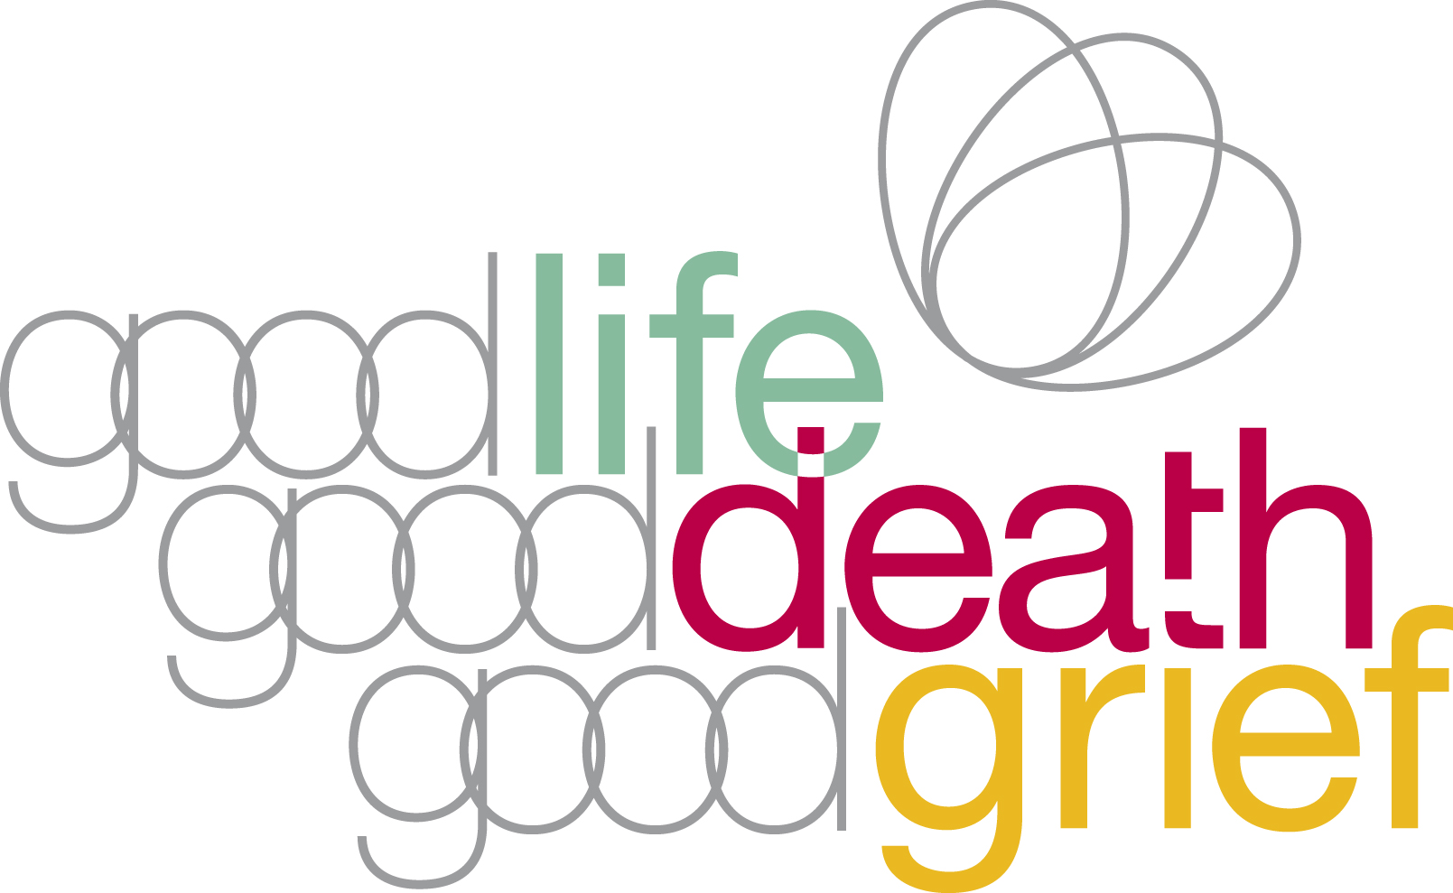

Part one – Your organisation

- What is your organisation’s name, address and bank details
Organisation name

Organisation’s address and post code

Organisation’s bank account number and sort code (where we will pay the money if your application is successful)

- What type of organisation are you? (please choose one)
Voluntary or community organisation Go to question 2.1

Statutory body (eg NHS Board, Council etc) Go to question 2.2

Other Go to question 2.3

2.1 Are you a registered charity? No Yes

If YES, what is your registered charity number?

2.2 What type of statutory body are you?

2.3 What type of organisation are you?

Part two – About your project or event
- Please describe the event for which you will use the funding, giving expected costs

- When will it take place?

- Where will it take place?

- How much are you applying for? (Max £50)

- Which of the aims of Good Life, Good Death, Good Grief are you trying to meet with this project or event? (please tick all that apply)

5.1 Help people to find ways of dealing with their

own experiences of death, dying and bereavement.

  - Help individuals and communities to support

those who are experiencing difficult times associated
with death, dying and bereavement.

  - Support NHS and social care staff and volunteers to

work compassionately and constructively with those
who are dying or have been recently bereaved.

  - Help people to make practical preparations for their

death, for example Will, Power of Attorney and
Advance Care Planning.

  - Promote openness/discussion of death, dying and

bereavement.

Part three – finishing your application
Please tick the boxes below to complete your application for funding

All the questions on the application form have been completed

You are authorised by your organisation to apply for funding

You agree to spend any funding allocated in line with the intentions
as set out in this application and by 31 May 2020.

You agree to supply brief feedback about your event using the form

which will be provided.

You have signed up as a member of Good Life, Good Death, Good Grief.

If you haven’t signed up you can do so at: http://www.goodlifedeathgrief.org.uk/content/sign_up/

Please now email a copy of this form to: susan.diotaiuti@palliativecarescotland.org.uk

Signed .................................................... Date ................................
Good Life, Good Death, Good Grief is an initiative of the Scottish Partnership for Palliative Care,
a Company Limited by Guarantee. Registered in Scotland No: 133003. Registered Charity SC017979

